Supporting Documents for 2.2.1
The Institution assesses the learning levels of the students and organizes special programmes for advanced learners and slow learners
1. Report on participation in inter-college competition for Advanced learners:
In 2020-21, under the guidance of Dr. Daimalu Brahma a group of students who have proficiency in Story writing, Spot poem writing, Debating, Dancing and Singing and other literary events were selected on the basis of their performances at Institutional level and encouraged to participate in 39th Ishan Mushahary Memorial Day Celebration Inter college competitions organised by Kokrajhar Govt. College on 16/12/2021, 17/12/2021 and 18/12/2021. Again another group of students were also selected to participate in inter-college competitions at 20th Annual Conference of the Bodo Department Teachers' Association held at Rangia College on 10/12/2021, 11/12/2021, 12/12/2021. The students bagged many prizes and proficiency certificates.

List of participants:
Date of event/activity (DD-MM-YYYY) | Name of the event/activity | Name of the student participated
16/12/2021, 17/12/2021, 18/12/2021 | 39th Ishan Mushahary Memorial Day Celebration organised by Kokrajhar Govt. College | Nabin Brahma
16/12/2021, 17/12/2021, 18/12/2021 |  | Abhinab Basumatary
16/12/2021, 17/12/2021, 18/12/2021 |  | Animias Basumatary
16/12/2021, 17/12/2021, 18/12/2021 |  | Ansuma Basumatary
16/12/2021, 17/12/2021, 18/12/2021 |  | Thulunga Boro
16/12/2021, 17/12/2021, 18/12/2021 |  | Bibungshar Brahma
16/12/2021, 17/12/2021, 18/12/2021 |  | Jayanta Rose Boro
16/12/2021, 17/12/2021, 18/12/2021 |  | Mijing Narzary
16/12/2021, 17/12/2021, 18/12/2021 |  | Geremsa Basumatary
16/12/2021, 17/12/2021, 18/12/2021 |  | Manoj Boro
16/12/2021, 17/12/2021, 18/12/2021 |  | Raesh Boro
16/12/2021, 17/12/2021, 18/12/2021 |  | Santosh Boro
16/12/2021, 17/12/2021, 18/12/2021 |  | Beena Basumatary
16/12/2021, 17/12/2021, 18/12/2021 |  | Fungkha Basumatary
16/12/2021, 17/12/2021, 18/12/2021 |  | Mithinga Basumatary
16/12/2021, 17/12/2021, 18/12/2021 |  | Nabajit Swargiary
 |  | Bimal Boro
 |  | Karabi Boro
 |  | Yulia Basumatary
10/12/2021, 11/12/2021, 12/12/2021 | 20th Annual Conference of the Bodo Department Teachers' Association at Rangia College | Jayanta Rose Boro
10/12/2021, 11/12/2021, 12/12/2021 |  | Abhinab Basumatary
10/12/2021, 11/12/2021, 12/12/2021 |  | Simanta Brahma
10/12/2021, 11/12/2021, 12/12/2021 |  | Ansuma Basumatary
10/12/2021, 11/12/2021, 12/12/2021 |  | Rajesh Boro
10/12/2021, 11/12/2021, 12/12/2021 |  | Nabin Brahma
10/12/2021, 11/12/2021, 12/12/2021 |  | Akan Narzary
10/12/2021, 11/12/2021, 12/12/2021 |  | Bibungshri Ramchiary
10/12/2021, 11/12/2021, 12/12/2021 |  | Dhanjita Boro
10/12/2021, 11/12/2021, 12/12/2021 |  | Nikumani Brahma
10/12/2021, 11/12/2021, 12/12/2021 |  | Mwira Basumatary
10/12/2021, 11/12/2021, 12/12/2021 |  | Pingwl Basumatary
10/12/2021, 11/12/2021, 12/12/2021 |  | Mamta Daimary

2. Group Discussions for Advanced Learners by Mathematics Department:
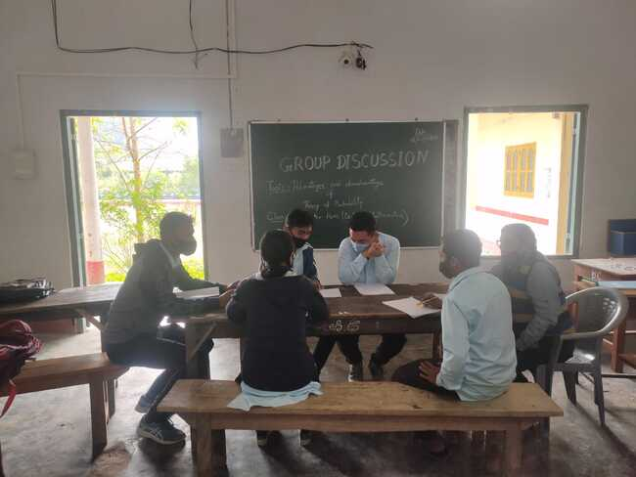
3.Projects for Advanced Learners:
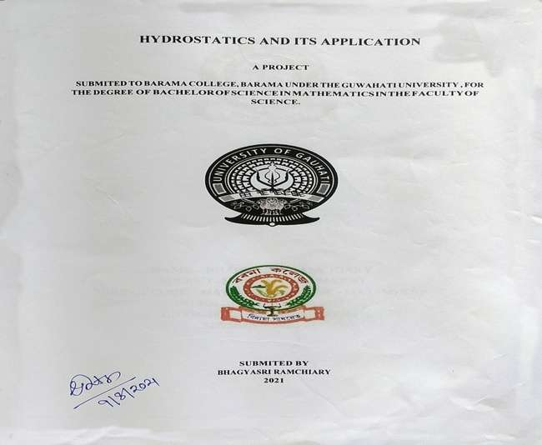
4. Additional mentoring and supply of reading materials for Slow Learners:

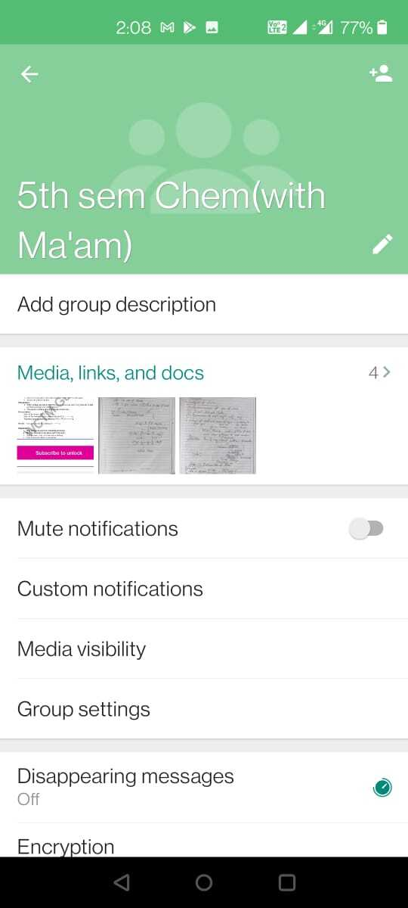
5. Home Assignments from the Department of History:
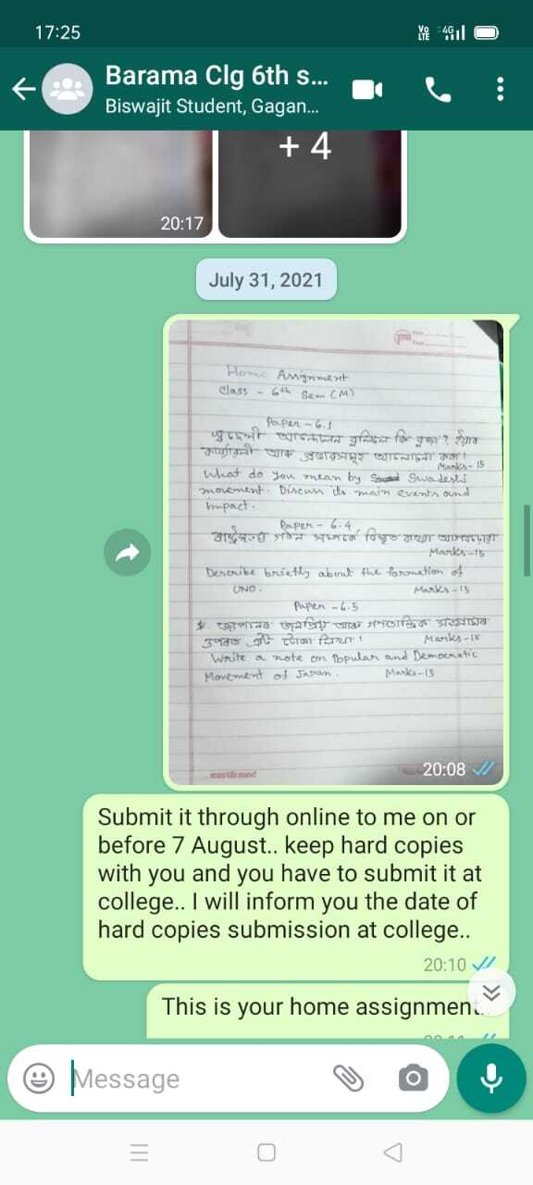

6. Supply of study materials through WhatsApp to Slow Learners:
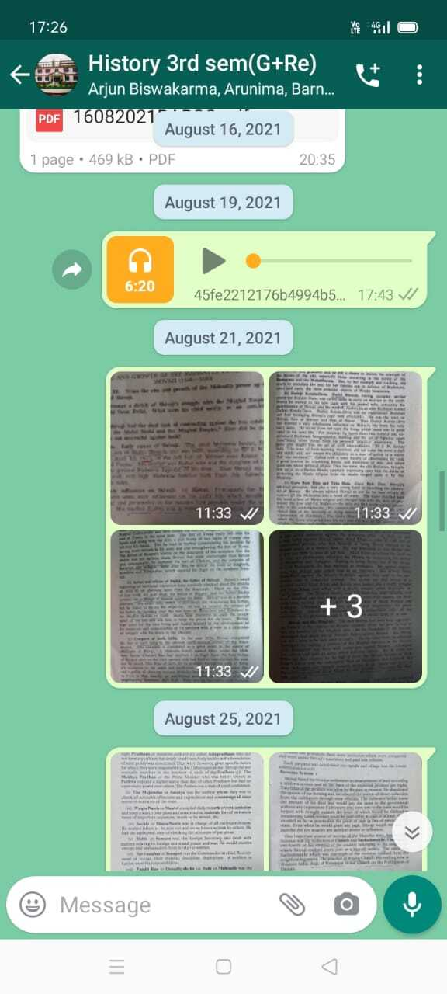

7. Career Counseling Programme for advanced learners:
A career counseling programme was organized in association with Teachers Unit, Barama College along with observation of International Women’s day.
Resource Person: Ranjan K. Baruah, Career Mentor and Founder of North East Youth Foundation.
Participant:145
Date.08-03-2021

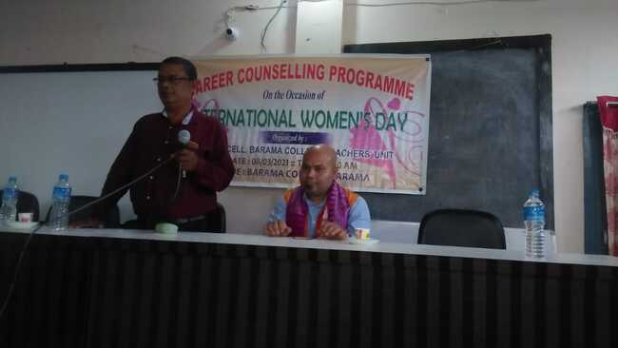
8. Seminar/Webinar:
Two days National Virtual Powered Seminar on “The Effective Use of E-books and E-media for learning”
Resource Person: Mr. Abhay Ranjan, Founder of ICT Academy; Dr. S. Seshadri, Secretary-International Federation for Theatre Research; Mr. Subhajit Bhattacharya, Senior Programme Manager, Innovation & Strategic Programmes, Accenture; Mr. Narendra Kumar N, Senior Manager, ICT Academy
Participant: 152
Date. 11-12 June/2021.
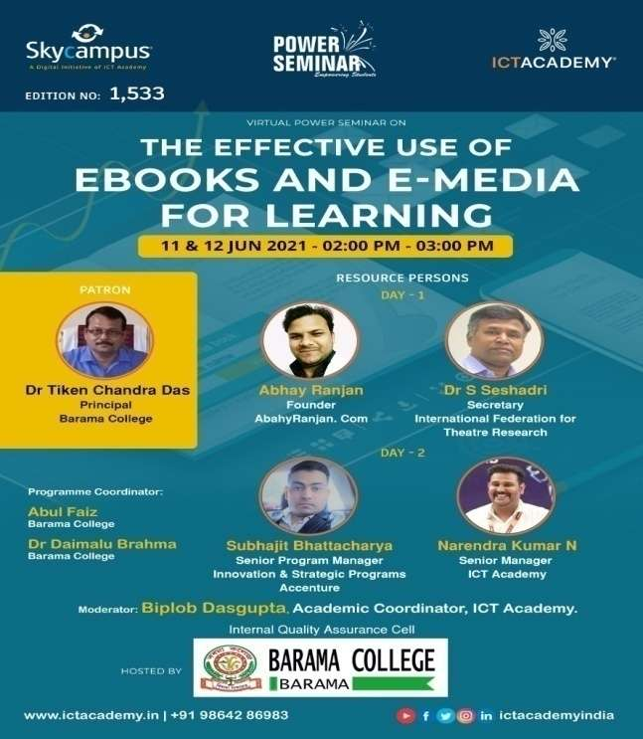

9. National Webinar on “Continuity and its perspective” in association with Department of Mathematics and ICT Academy
Resource Person: Dr. Debasish Bhattacharjee, Assistant Professor Dept. of Mathematics, GU
Participant: 150
Date. 2nd July/2021
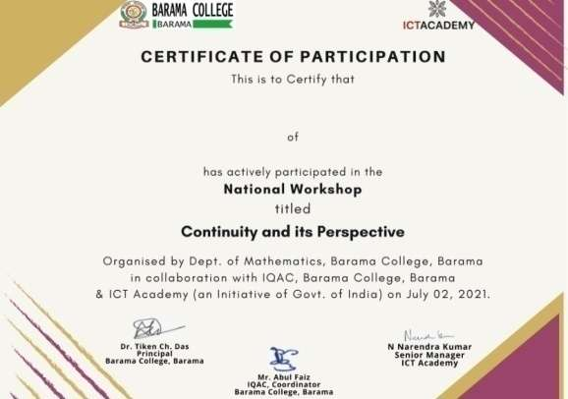 | 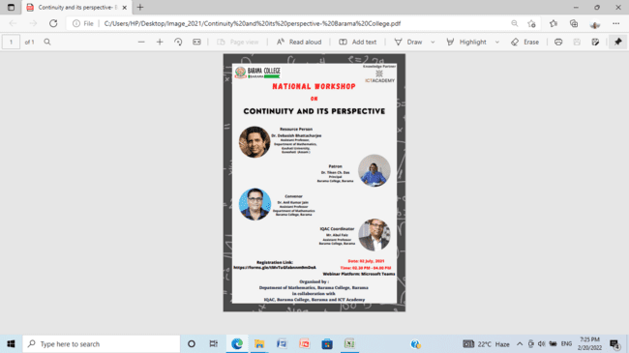
10. Two day training programme on Mushroom Spawn Production and Cultivation.
Resource Person: Mr. Bahrul Islam, Retd. Chief Technical Officer, ICAR, Meghalaya
Participant: 50
Date. 28-29 December/2021
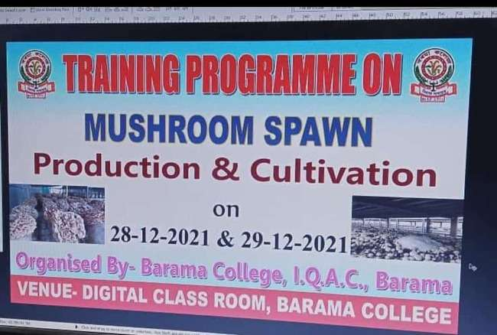 |  | 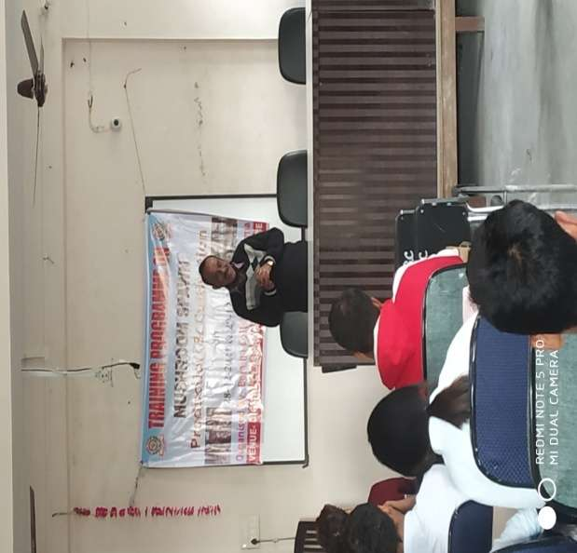

11. A lecture programme on Science of Memory, Concentration & Human Value was organized and the Resource Person invited was renowned speaker Dr. E. V. Swaminathan on 06-10-21.
Participant-300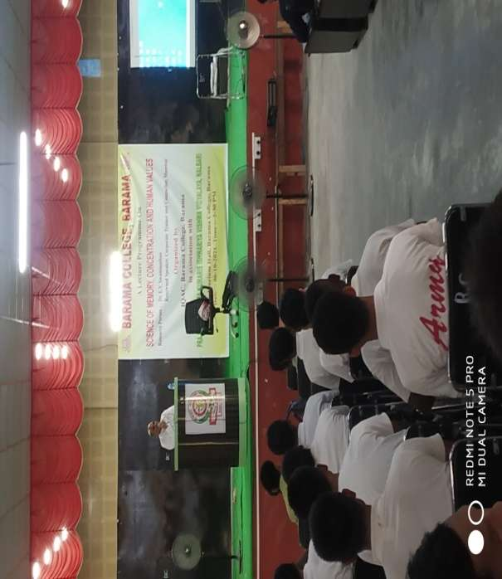
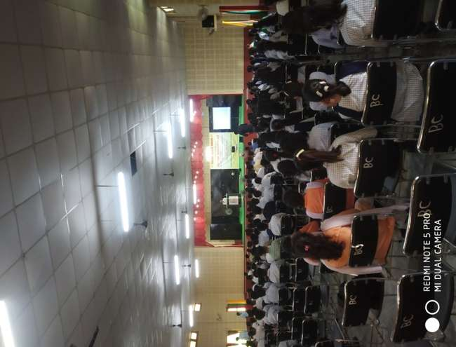

12. Online Quiz on Ethology for BSc (Zoology), Sem VI
